How to use WIFI and set WIFI
The wifi interface of device support TCP Client Mode. And WIFI encryption method is WPA2-PSK.
The wireless route should set password, should not set null password.
Step 1:
Please check whether or not your reader with WIFI, if not, please buy wifi reader first.
Step 2: Open WIFI interface.
Open ReaderSoft file path
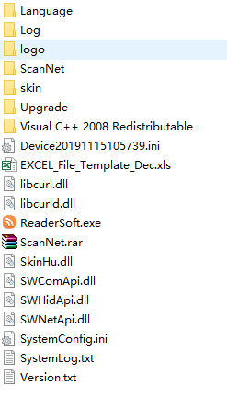
Double click ReaderSoft.exe logo.
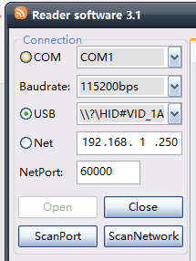, Choose connect port, such as COM, USB or Net(RJ45)
Then click Open button, it will show like this picture
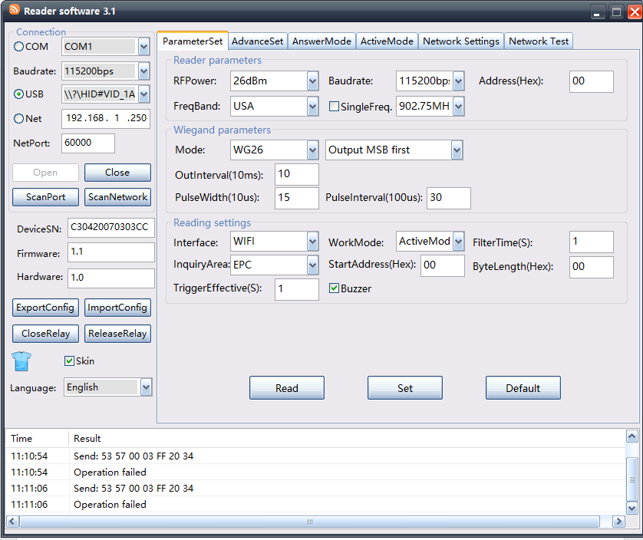
Pic 1
Or like as below:
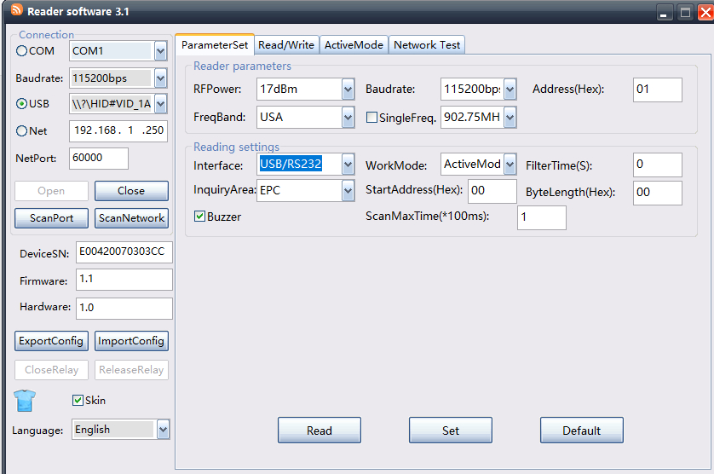
Pic 2
Select Interface is WIFI, and select WorkMode is ActiveMode.
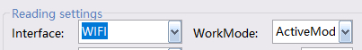
When the soft show like Pic 2 show, if select WIFI interface, it will show WIFI setting parameters, like below picture.
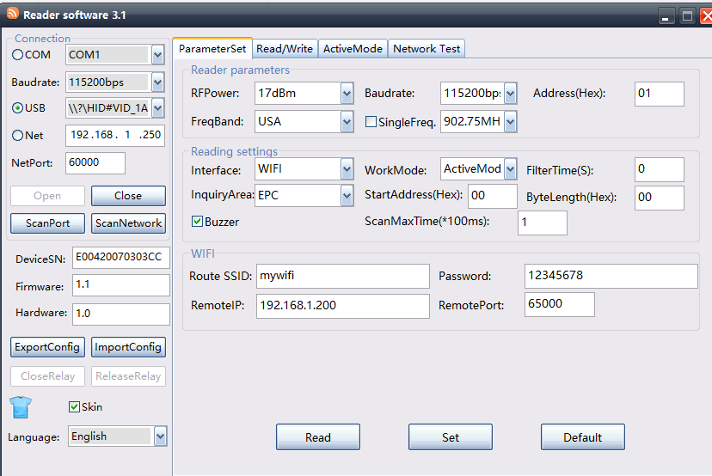
Route SSID is wireless Route SSID name.
Password is wireless Route password, it can not be empty.
RemoteIP is TCP Server IP or domain name ( such as www.google.com, not with http://)
RemotePort is TCP Server Listening Port.
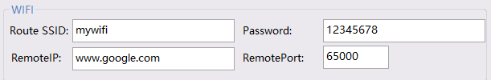
RemoteIP of domain name should not with http://， and not support HTTPS encrypt web.
After set over, click Set button, if show paramters error, pls click read button first then set .
If show like pic 1, it need set WIFI params at Network Settings
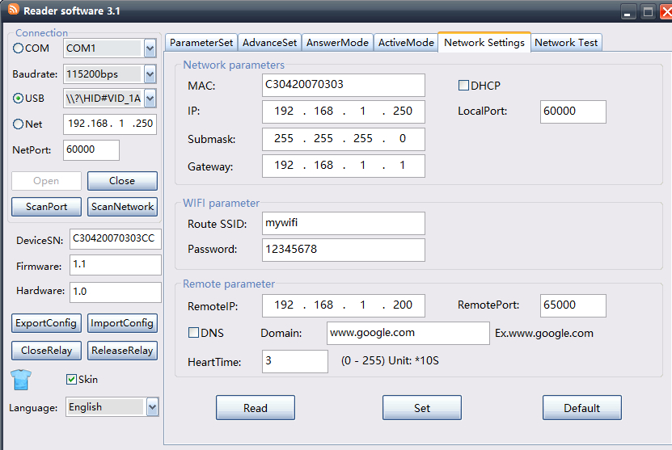
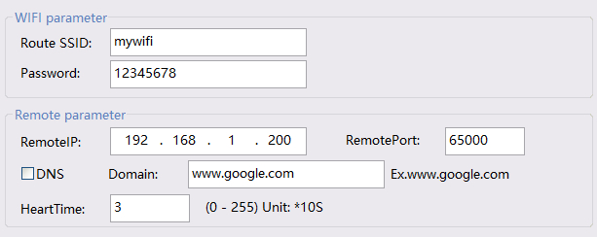
DNS mean open server domain mode, if open DNS, please input domain name such as www.google.com not with http:// , and RemoteIP is invalid. And it not support HTTPS encrypt web.
After set over, click Set button, if show paramters error, pls click read button first then set .
For reduce data package and speed up transmission, you can set filterTime, set up zero mean open filterTime.
ParamSet -> FilterTime
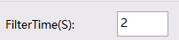
After set these parameters, WIFI is opened now.
You can use SDK->TcpServer soft to test wifi or use NetwortTest table
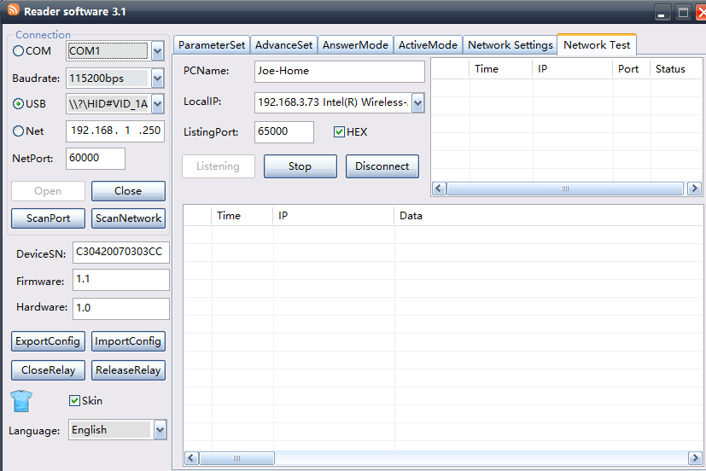
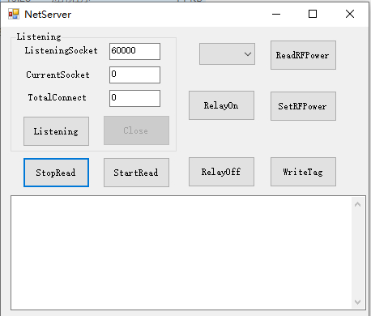
ListeningSocket is wifi param of RemotePort.

If you want to develop soft, use SDK->TcpServer file path to develop
Or SDK->Android->TcpServerDemo
Or SDK->QT_Linux->TcpServer
Or SDK->NodeJS->TcpServer
Or SDK->RaspberryPi->TcpServer

